

THE UNIVERSITY OF AZAD JAMMU AND KASHMIR, MUZAFFARABAD

DEPARTMENT OF SOFTWARE ENGINEERING

Name: | Ayesha Akram
Roll no: | 2024-SET-07
Course Title: | Image Processing Technology
Course Code: | ET-3106
Semester: | 5th
Session: | 2024-2028
Submitted to: | Engr. Sidra Rafique
Lab report 03
Introduction

Python is a high-level programming language widely used in software development, data analysis, artificial intelligence, and image processing. It provides several powerful libraries that make programming tasks easier and more efficient.
In this lab, we explored three important technologies: Python, NumPy, and OpenCV. NumPy is used for numerical calculations and array operations, while OpenCV is a computer vision library used for image processing and manipulation.
We performed practical tasks using Google Colab, including creating arrays, calculating sum and average, creating images, displaying text on images, extracting RGB channels, converting images into grayscale, and applying thresholding techniques.

Objectives

The main objectives of this lab are:
1. To understand the basic concepts of Python programming.
2. To learn how to use the NumPy library.
3. To create and manipulate NumPy arrays.
4. To calculate the sum and average of array elements.
5. To understand basic image processing using OpenCV.
6. To create and display images using Python.
7. To extract RGB colour channels from an image.
8. To convert colour images into grayscale.
9. To understand and apply global and adaptive thresholding.
10. To perform basic image operations using Google Colab.

Lab tasks:
Task 1: Working with NumPy Arrays
Objective: Create a NumPy array and calculate its sum and average.

Python Code:
import numpy as np
numbers = np.array([10,20,30,40,50])
print("Numbers:", numbers)
print("Sum:", np.sum(numbers))
print("Average:", np.mean(numbers))

Explanation:
- `import numpy as np` imports the NumPy library.
- `np.array()` creates a NumPy array.
- `np.sum()` calculates the total of all array elements.
- `np.mean()` calculates the average of the elements.
- `print()` displays the results.

Screenshot:
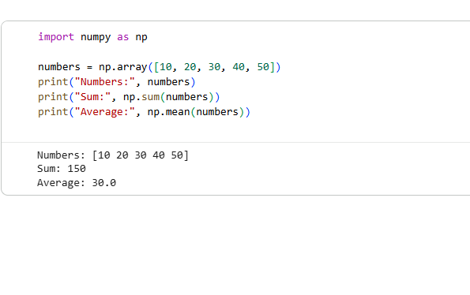
Task 2: Change the NumPy Array and Calculate Sum and Average
Objective: Change the numbers array to `[5, 10]` and calculate its sum and average.

Python Code:
import numpy as np
numbers = np.array([5, 10])
print("Numbers:", numbers)
print("Sum:", np.sum(numbers))
print("Average:", np.mean(numbers))

Explanation:
1. NumPy library is imported.
2. An array containing 5, 10 is created.
3. `np.sum()` calculates the total of all numbers.
4. `np.mean()` calculates the average.

Screenshot:
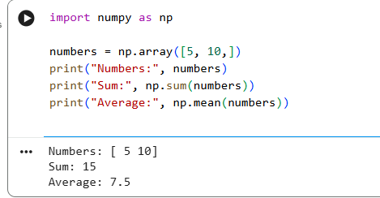

Task 3: OpenCV: basic image processing

Objective: OpenCV is a library used for computer vision and image processing, such as reading images, resizing them, and analysing video.
Python code:
import cv2
import numpy as np
from google.colab.patches import cv2_imshow

print("OpenCV version:", cv2.__version__)

image = np.zeros((300, 400, 3), dtype=np.uint8)

cv2.putText(
image,
"Hello OpenCV!",
(40, 150),
cv2.FONT_HERSHEY_SIMPLEX,
1,
(255, 255, 255),
2
)

cv2_imshow(image)

Screenshot:
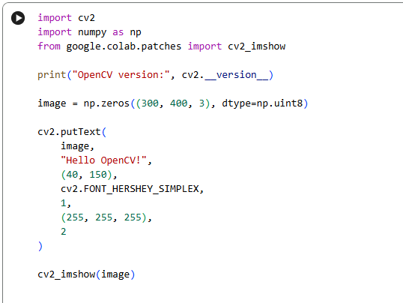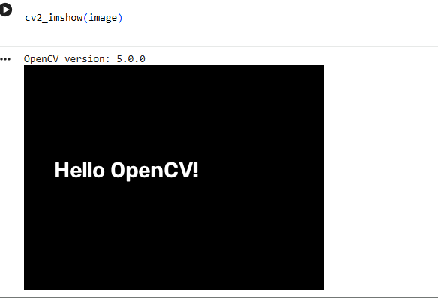
Task 4: Change the Text in the OpenCV Program
Objective: Replace the existing text in the OpenCV program with a custom message.
Python Code:
import cv2
import numpy as np
from google.colab.patches import cv2_imshow
image = np.zeros((300, 400, 3), dtype=np.uint8)
cv2.putText(
image,
"ayesha akram!",
(40, 150),
cv2.FONT_HERSHEY_SIMPLEX,
1,
(255, 255, 255),
2
)
cv2_imshow(image)

Explanation:
1. OpenCV and NumPy libraries are imported.
2. A black image is created.
3. The original text is replaced with "ayesha akram!".
4. `cv2.putText()` adds the custom message to the image.
5. `cv2_imshow()` displays the final image.
Screenshot:

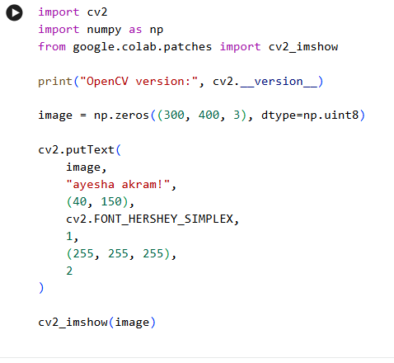
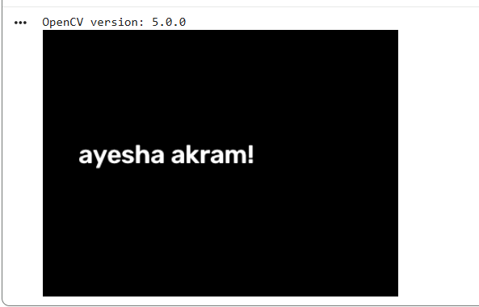
Task 5: Change the Image Dimensions
Objective: Change the image dimensions from `(300, 400, 3)` to `(200, 500, 3)`.

Python Code:
import cv2
import numpy as np
from google.colab.patches import cv2_imshow
image = np.zeros((200, 500, 3), dtype=np.uint8)
print("Image Shape:", image.shape)
cv2_imshow(image)

Explanation:
1. NumPy and OpenCV libraries are imported.
2. `np.zeros()` creates a black image.
3. The image dimensions are changed to `(200, 500, 3)`.
4. The first value represents height (200 pixels).
5. The second value represents width (500 pixels).
6. The third value represents three colour channels.
7. `image.shape` displays the dimensions of the image.

Screenshot:

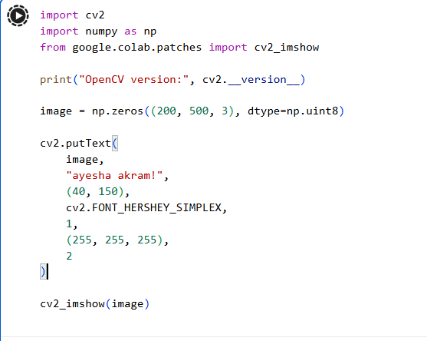
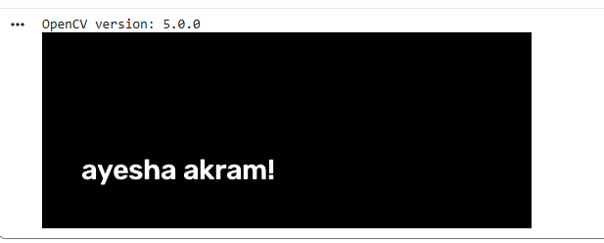
Task 6: Change the Text Colour to Red
Objective: Change the text colour to red using the BGR colour format in OpenCV.

Python Code:
import cv2
import numpy as np
from google.colab.patches import cv2_imshow
image = np.zeros((200, 500, 3), dtype=np.uint8)
cv2.putText(
image,
"Red Text in OpenCV!",
(40, 110),
cv2.FONT_HERSHEY_SIMPLEX,
1,
(0, 0, 255),
2
)
cv2_imshow(image)

Explanation:
1. OpenCV and NumPy libraries are imported.
2. A black image of size 200 × 500 is created.
3. `cv2.putText()` adds the custom text.
4. The colour value `(0, 0, 255)` represents red in OpenCV's BGR format.
5. The image is displayed using `cv2_imshow()`.

Screenshot:

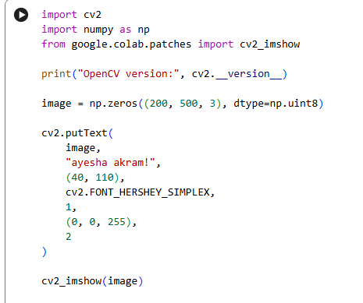
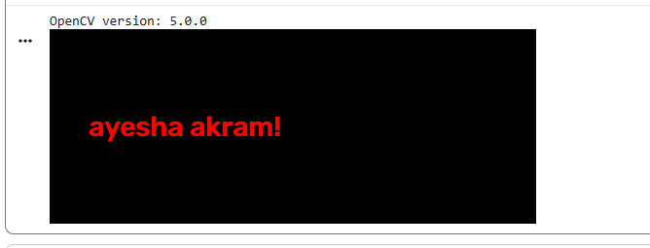
Task 7: Load and Display an Image
Objective: Load an image and display it using Matplotlib.

Python Code:
import cv2
import numpy as np
import matplotlib.pyplot as plt
from skimage import data
# Load sample image
img = data.coffee ()
# Display image
plt.imshow(img)
plt.axis('off')
plt.show()
# Display image dimensions
print("Image Shape:", img.shape)

Explanation:
- `data.coffee()` loads a sample RGB image.
- `plt.imshow()` displays the image.
- `plt.axis('off')` hides the axis.
- `plt.show()` displays the final image.
- `img.shape` shows the image dimensions.

Screenshot:

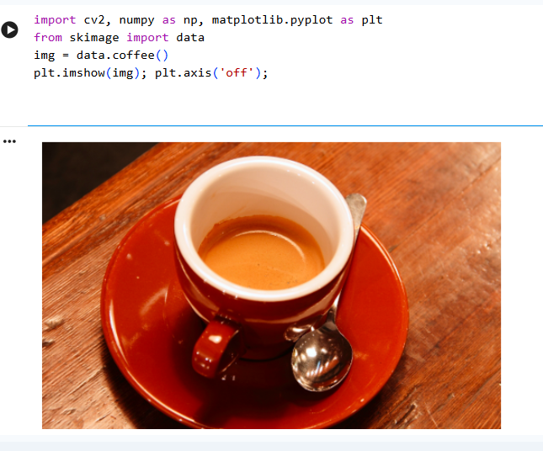
Task 8: Display RGB Components
Objective: Extract and display the Red, Green, and Blue channels separately.

Python Code:
R, G, B = cv2.split(img)
fig, ax = plt.subplots(1, 3, figsize=(10, 3))
ax[0].imshow(R, cmap='Reds')
ax[0].set_title('Red Channel')
ax[1].imshow(G, cmap='Greens')
ax[1].set_title('Green Channel')
ax[2].imshow(B, cmap='Blues')
ax[2].set_title('Blue Channel')
for a in ax:
a.axis('off')
plt.show()

Explanation:
- `cv2.split(img)` separates the image into three channels.
- `R` stores the red channel.
- `G` stores the green channel.
- `B` stores the blue channel.
- `imshow()` displays each channel separately.
- `cmap` applies a colour map for visualization.

Screenshot:

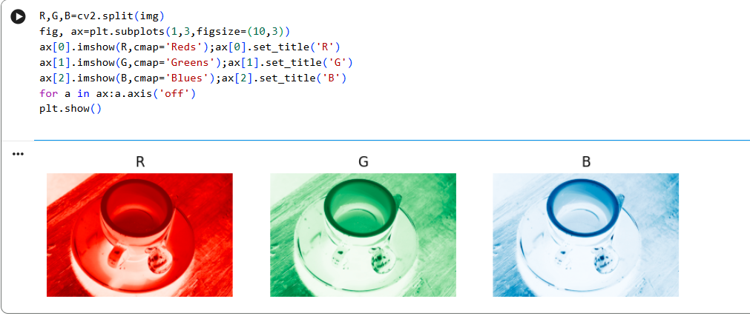
Task 9: Convert Image into Grayscale
Objective: Convert the original RGB image into a grayscale image.

Python Code:
gray = cv2.cvtColor(img, cv2.COLOR_RGB2GRAY)
print("Grayscale Shape:", gray.shape)
print("Data Type:", gray.dtype)
plt.imshow(gray, cmap='gray')
plt.axis('off')
plt.show()

Explanation:
- `cv2.cvtColor()` converts the image colour space.
- `cv2.COLOR_RGB2GRAY` converts RGB into grayscale.
- `gray.shape` displays the new image dimensions.
- `gray.dtype` displays the data type.
- `cmap='gray'` displays the image in grayscale.

Screenshot:

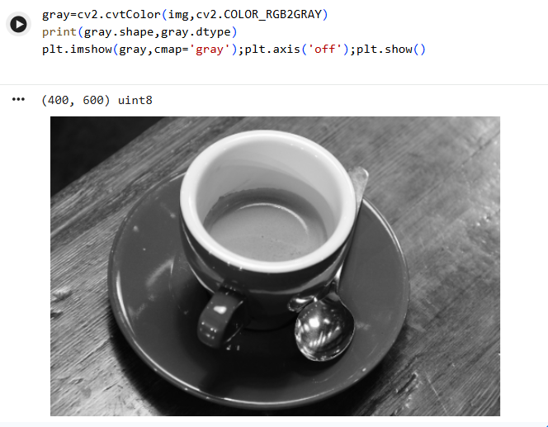
Task 10: Apply Global and Adaptive Thresholding
Objective: Apply global and adaptive thresholding to the grayscale image.

Python Code:
# Apply global thresholding
_, binary = cv2.threshold(
gray, 128, 255, cv2.THRESH_BINARY
)
# Apply adaptive thresholding
adaptive = cv2.adaptiveThreshold(
gray,
255,
cv2.ADAPTIVE_THRESH_GAUSSIAN_C,
cv2.THRESH_BINARY,
31,
5
)
# Display both results
fig, ax = plt.subplots(1, 2, figsize=(8, 3))
ax[0].imshow(binary, cmap='gray')
ax[0].set_title('Global Thresholding')
ax[1].imshow(adaptive, cmap='gray')
ax[1].set_title('Adaptive Thresholding')
for a in ax:
a.axis('off')
plt.show()

Explanation:
- `cv2.threshold()` applies a fixed threshold value.
- `128` is the threshold value.
- `255` is the maximum output value.
- `cv2.THRESH_BINARY` creates a binary image.
- `cv2.adaptiveThreshold()` calculates local threshold values.
- `cv2.ADAPTIVE_THRESH_GAUSSIAN_C` uses a Gaussian-weighted neighbourhood.
- `31` specifies the block size.
- `5` is the constant subtracted from the calculated threshold.

Screenshot:

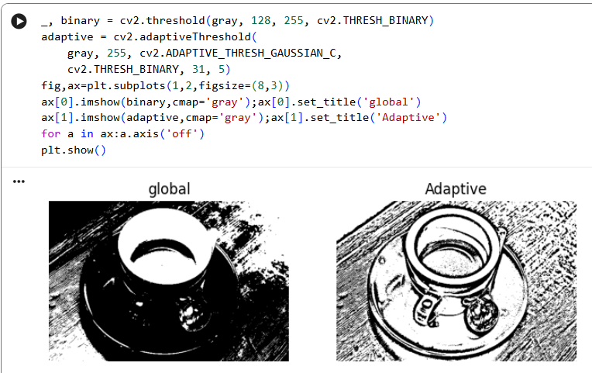
Conclusion

In this lab, we successfully learned the basic concepts of Python, NumPy, and OpenCV. We created NumPy arrays and performed numerical calculations, including sum and average. We also used OpenCV to create images, change image dimensions, and display custom red text.
Furthermore, we learned basic image processing operations, including image loading, RGB channel separation, grayscale conversion, and global and adaptive thresholding.
Overall, this practical lab improved our understanding of Python programming and introduced us to fundamental image processing techniques used in computer vision and artificial intelligence.

